**UNIT - I**

1. Imagine a small office environment where ten computers are connected using a bus topology. The office uses a single coaxial cable as the backbone, and each computer is connected to this cable using a T-connector. The network employs CSMA/CD (Carrier Sense Multiple Access with Collision Detection) as its access method.One day, an employee in the office notices that they cannot connect to the network. Soon after, several other employees report similar issues. Upon investigation, it is found that the network failure is widespread. Describe the potential cause(s) of this failure in a bus topology network. How would you troubleshoot and resolve this issue?
2. Imagine you are tasked with setting up a network for a new office with 25 systems. How would you design and configure a star topology using Packet Tracer to meet the company's connectivity and performance requirements?
3. In a mid-sized law office with 15 computers connected in a star topology, the central switch fails. Explain the impact on the network and suggest an immediate and long-term solution to prevent future failures.
4. A hospital with 12 critical systems connected in a mesh topology experiences a node failure. Discuss how the mesh topology manages this situation and evaluate the effectiveness of the network's redundancy.
5. A healthcare network with 28 systems uses a hybrid topology. They plan to expand by adding a new facility with 12 more systems. Discuss the integration challenges and how to ensure continuous network performance.
6. A government agency with 20 systems in a mesh topology needs to ensure data security and redundancy. Discuss how mesh topology supports these needs and suggest additional security measures.
7. A large retail chain uses a tree topology with 22 systems. The root node fails, causing widespread network outages. Explain the impact and outline a backup plan to ensure network availability in such scenario
8. A legal firm with 15 computers in a star topology frequently experiences slow network speeds. The central switch is suspected to be the bottleneck. Recommend strategies to alleviate this bottleneck and enhance overall performance.
9. A university's IT department is managing a network with 20 systems in a tree topology. They need to add 5 more systems without disrupting the network. Describe the steps required and the considerations for maintaining network stability.
10. Design a computer lab with ten PCs, two switches, and a router. Implement proper IP addressing and subnetting to ensure communication.
11. A small bookstore has 8 computers connected via a bus topology. Lately, the staff has experienced frequent network disconnections. Identify the likely causes and suggest a troubleshooting process. What steps can be taken to prevent these issues in the future?
12. How could you implement a hybrid topology in Packet Tracer to support a remote learning environment, allowing students to interact with teachers and access educational materials effectively?
13. A school district with 16 systems in a tree topology needs to connect various schools to a central administrative office. How does the tree topology facilitate this connection? What measures can ensure reliable communication and data sharing?
14. A financial institution with 20 systems in a mesh topology handles sensitive transaction data. How does the mesh topology enhance security and redundancy for financial applications? What additional precautions should be taken?
15. A small publishing house with 9 systems in a bus topology produces and distributes digital content. What are the limitations of this topology for handling large data files? How can the network be optimized for better performance?
16. A cloud service provider with 18 systems in a mesh topology offers various cloud-based services. How does the mesh topology enhance redundancy and reliability for these services? What additional security measures should be considered?
17. A graphic design studio with 15 systems in a star topology relies on high-speed data transfers for large file sharing. How does the star topology support this need? What strategies can be employed to maintain optimal performance?
18. A small coffee shop with 5 systems connected in a bus topology provides free Wi-Fi to customers. What are the potential drawbacks of this setup for public access? How can the coffee shop ensure a secure and stable network?
19. A university campus with 20 systems in a tree topology needs to connect various departments to a central server. How does the tree topology facilitate this structure? What steps can be taken to ensure efficient data flow and network stability?
20. A small call center with 12 systems in a star topology requires reliable VoIP communication. How does the star topology support this application? What measures can be taken to ensure low latency and high call quality?

**UNIT - II**

1. A network administrator notices that two devices on the same subnet are experiencing intermittent connectivity issues. After running an ARP scan, they find that both devices have the same MAC address. How can ARP help diagnose and resolve this IP address conflict? What steps should be taken to correct the issue and prevent it from happening again?
2. Describe the process of using Packet Tracer to analyze ARP traffic in a small business network for troubleshooting connectivity issues.
3. A security analyst suspects that a man-in-the-middle attack is occurring on their network, causing sensitive information to be intercepted. How can ARP spoofing contribute to such an attack? What are the signs of ARP spoofing, and what mitigation techniques can be employed to protect the network from these types of attacks?
4. Users in a particular subnet are reporting that they cannot access certain network resources. The network engineer decides to use ARP to diagnose the problem. How can ARP be used to identify whether the issue is related to IP-to-MAC address mapping? What commands and tools can assist in this troubleshooting process, and what would a typical resolution look like?
5. In a virtualized environment, LLDP is used to ensure proper network connectivity for virtual machines. How does LLDP assist in managing virtual network connections? What challenges can LLDP help address in a virtualized setup?
6. LLDP is used to verify redundant network paths in a high-availability setup. How can LLDP help ensure redundancy is correctly configured? What steps should be taken to validate redundancy using LLDP data?
7. During a network audit, you are tasked with verifying the physical topology of a network against the logical topology diagrams. Use Packet Tracer to simulate the current network setup and enable LLDP on all devices. Conduct the simulation and analyze the LLDP information to verify the physical connectivity of devices.
8. You have a network topology with multiple switches connected in a hierarchical structure. Each switch is configured to use the Link Layer Discovery Protocol (LLDP).Given the network topology.
9. Create a wireless network using CSMA/CA and analyze its efficiency compared to a wired network.
10. Set up a collision domain using CSMA/CD and observe how collisions are resolved. Create a wireless network using CSMA/CA and analyze its efficiency compared to a wired network.
11. Build a network of 6 computers, which are connected through a hub. Provide , proper configuration of IP addresses and show that the communication between any various computers at the same time. Analysis of network with CSMA/CD and CSMA/CA .
12. Configure the network in Packet Tracer to use CSMA/CD. Simulate data collisions and analyze how CSMA/CD resolves these collisions.
13. Using C program, Implement and demonstrate the generation of bit stuffing through accepting inputs from the user for the given data ( data :1011111100110).
14. Using a C program, implement and demonstrate the generation of bit stuffing for the given data 1111100001111.
15. Write C program receives the input data 1111000011 and applies bit stuffing. Explain how the program handles sequences of consecutive 1s and modifies the data accordingly. What is the final output after bit stuffing is applied?
16. Write a C program that implements bit stuffing with the input data sequence 1101101111. Describe how the program identifies the sequence of five consecutive 1s and determines where to insert a 0 for bit stuffing.
17. Capture and analyze ARP and HTTP headers in Wireshark to understand address resolution and web communication.
18. Simulate ARP traffic between devices and analyze the ARP table entries on each device.
19. Using Wireshark, how can one capture and analyze ARP and HTTP headers to gain insights into address resolution mechanisms and web communication protocols?
20. A company is experiencing network performance issues, with some packets being delayed or dropped. The network team suspects an ARP-related problem, such as an ARP cache overflow or frequent ARP broadcasts. How can ARP contribute to network performance issues, and what strategies can be implemented to monitor and optimize ARP performance in the network?

**UNIT III**

1. Configure IPv4 addresses on multiple devices. Create a network with three PCs and a switch. Assign IPv4 addresses to each PC and configure the switch. How do you verify connectivity between the PCs using IPv4 addresses?
2. Configure IPv4 addresses on multiple devices.Create a network with three PCs and a HUB. Assign IPv4 addresses to each PC and configure the Hub. How do you verify connectivity between the PCs using IPv4 addresses?
3. Configure the network with multiple devices to make with IP address using Datagram approach.
4. Configure the network with multiple devices to make with IP address using packet switching networks.
5. Implement subnetting in an IPv4 network.Create a network with one router and four PCs. Subnet the network to provide unique subnets for each PC. Demonstrate the process of subnetting and calculate the subnet addresses used in your network.
6. Design the network model for Subnetting – Class C Addressing using packet tracer.
7. Using Packet tracer, configure frame relay mechanism using static maps and the given topology.

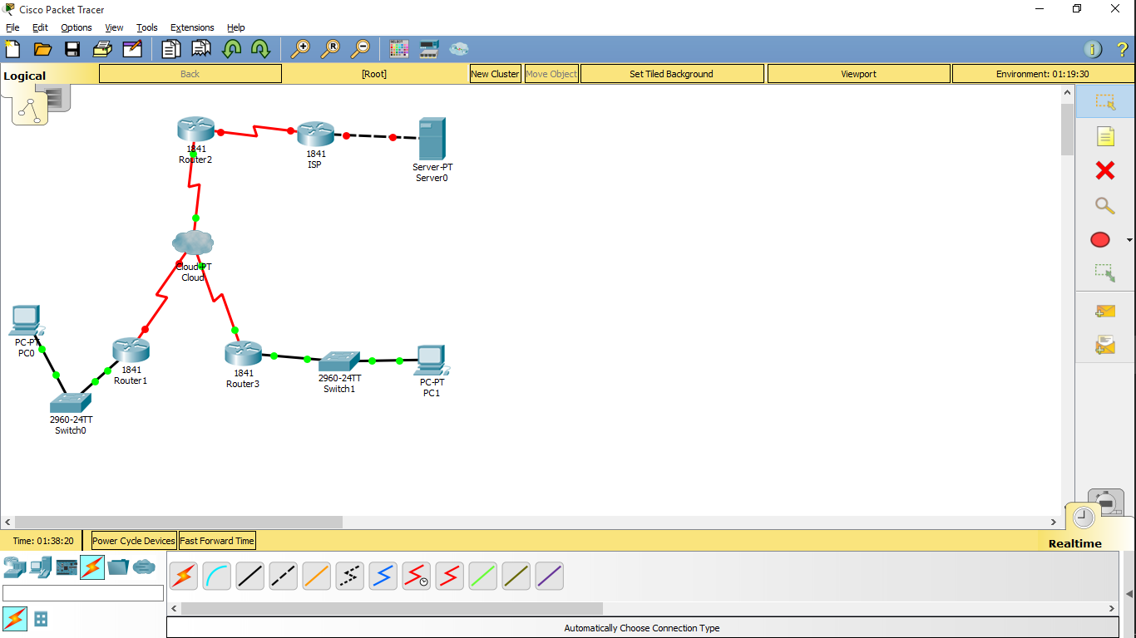

1. Implement static routing in a network. Create a network with two routers and four PCs. Configure static routes on each router to ensure all PCs can communicate. Explain the steps to configure static routing and verify connectivity between PCs.
2. Implement dynamic routing using a routing protocol.Create a network with two routers and six PCs. Configure a dynamic routing protocol such as OSPF.How does dynamic routing differ from static routing? Verify and analyze the routing tables
3. Using Wireshark, Capture and analyze the Packets that uses IP for different header fields and payload of the concerned packet.
4. Using Wireshark, Capture and analyze the Packets that uses ICMP for different header fields and payload of the concerned packet.
5. Using Wireshark, Capture and analyze the Packets that uses IPV6 for different header fields and payload of the concerned packet.
6. Use Wireshark to capture routing protocol traffic (e.g., OSPF or RIP) on your network. Analyze the captured packets to understand how routing information is exchanged between routers and how routing tables are built and updated.
7. Capture and analyze multicast traffic using Wireshark. Identify multicast packets and explain how multicast addresses are used in the IP header. Compare the handling of multicast traffic with unicast and broadcast traffic.
8. Write a C program to validate an IPv4 address. The program should check if the given string is a valid IPv4 address and print an appropriate message.
9. Write a C program to simulate a simple packet switching network using the datagram approach. The program should handle multiple packets and route them to their destinations through a predefined network topology.
10. Implement the Distance Vector Routing algorithm in C. The program should simulate a network with a predefined number of nodes and their respective distances, and then compute the routing table for each node.
11. Write a C program to implement the Link State Routing algorithm. The program should use Dijkstra's algorithm to find the shortest path from a source node to all other nodes in the network.
12. Write a C program to implement the basic functionality of the Internet Control Message Protocol (ICMP). The program should be able to send and receive ICMP echo requests and replies (ping).
13. Write a C program to calculate the network address, broadcast address, and the range of valid host addresses for a given IPv4 address and subnet mask.

**UNIT IV**

1. Using Packet tracer, create a network topology as shown in the below diagram. Use generic routers with appropriate configurations and IP addresses. Demonstrate the principle of working of any dynamic routing protocol.

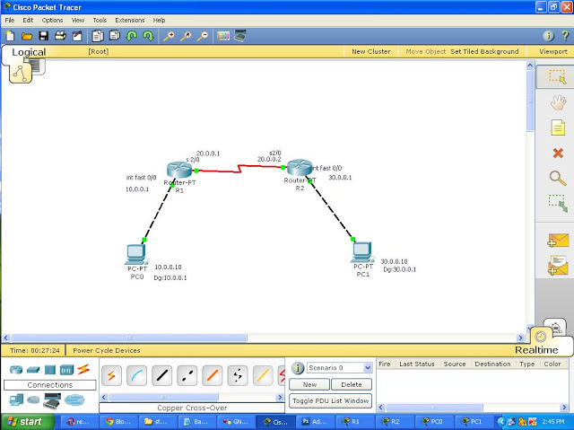

1. Configuration Of Link State Routing(OSPF) Using Packet Tracer

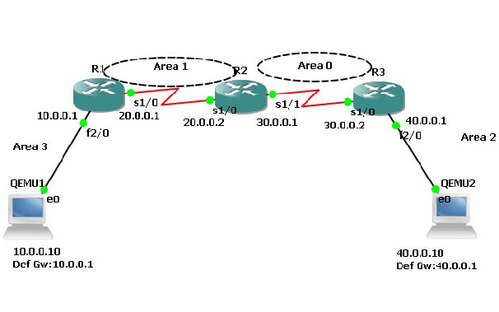

1. Set up a network where a PC sends a large file to another PC using TCP. Monitor the traffic using Packet Tracer. How does TCP ensure reliable data transmission?
2. Create a network with two PCs connected via a router. Configure TCP on one PC to establish a connection with the other PC. What are the three-way handshake steps for establishing a TCP connection? using packet tracer.
3. Create a network with two PCs and a router. Configure UDP on one PC to send data to the other PC.What are the primary differences between TCP and UDP?
4. Using Packet tracer, Provide, proper configuration of DHCP (dynamic host configuration protocol). and show that the communication between any two computers are successful.
5. Using Packet tracer, create a network topology as shown in the below diagram. Use generic routers with appropriate configurations and IP addresses as given in the diagram and demonstrate the principle of working of routing information protocol.

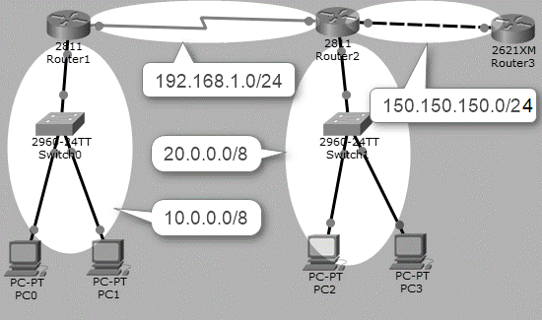

1. Using Packet tracer, create a network use generic routers with appropriate configurations and IP addresses using TCP and demonstrate the principle of working of transmission control Protocol.
2. Using Packet tracer, create a network use generic routers with appropriate configurations and IP addresses using UDP and demonstrate the principle of working of user datagram Protocol.
3. Using Socket programming techniques, implement client server application of chat using TCP based transmission. Your code should involve separate client side and server side in two different terminals.
4. Using Socket programming techniques, implement client server chat application using UCP based transmission. Your code should involve separate client side and server side in two different terminals.
5. Write a C program to implement multicast communication using UDP sockets. The program should allow a sender to transmit messages to multiple receivers simultaneously.
6. Write a C program to simulate the three-way handshake process in TCP. The program should demonstrate the SYN, SYN-ACK, and ACK messages exchanged between a client and a server.
7. Write a C program to simulate TCP congestion control using the additive increase/multiplicative decrease (AIMD) algorithm. The program should adjust the congestion window size based on packet loss events.
8. Using Wireshark, Capture and analyze the Packets that uses TCP for different header fields and payload of the concerned packet.
9. Using Wireshark, Capture and analyze the Packets that uses UDP for different header fields and payload of the concerned packet.
10. Use Wireshark to capture a file transfer session over TCP. Analyze the sequence and acknowledgment numbers in the captured packets and explain how TCP ensures reliable data transfer.
11. Capture a TCP session experiencing congestion using Wireshark. Analyze the captured packets to observe how TCP congestion control mechanisms (such as slow start and congestion avoidance) are applied.
12. Capture a UDP communication session between a client and a server using Wireshark. Compare the UDP packets with TCP packets and explain the differences in how data is transmitted.
13. Capture and analyze a TCP connection establishment process using Wireshark. Identify and explain the key duties of the transport layer observed during the three-way handshake process.

**UNIT V**

1. A healthcare provider uses 5 remote IoT monitoring devices for home patients. How can the network ensure secure and reliable data transmission to healthcare professionals? What measures can protect patient data privacy?
2. A city deploys 16 IoT sensors for environmental monitoring (air quality, water levels and soil moisture). What strategies can ensure timely data collection and processing? How can the network be designed to handle sensor data overload?
3. A healthcare facility integrates 12 wearable IoT devices for patient monitoring. How can data from these devices be securely transmitted to central servers? What protocols should be in place to protect patient privacy?
4. A smart city project deploys 15 IoT traffic sensors to monitor and manage traffic flow. What are the challenges in ensuring real-time data transmission and processing? How can the network handle the high data volume?
5. A farm uses 15 IoT sensors for soil moisture, temperature, and crop health monitoring. How can data be effectively collected and analyzed? What measures can be taken to ensure sensor data accuracy and reliability?
6. A smart home system with 10 IoT devices (thermostats, lights, security cameras) experiences intermittent connectivity issues. What could be causing these issues? How can the network be optimized for reliable device communication?
7. A smart office setup includes 10 IoT devices for lighting, climate control, and security. How can the network ensure seamless integration and control of these devices? What security measures protect against potential cyber threats?
8. Design an IoT-based smart home network with various sensors and actuators using Packet Tracer.
9. A utility company installs 8 IoT smart meters for energy consumption monitoring. How can the network support real-time data collection from all meters? What measures prevent data loss and ensure accurate energy consumption tracking?
10. Create a small network consisting of three PCs, one switch, and one hub. Configure each PC with IP addresses and demonstrate communication between them using the hub and switch.
11. A farm uses 20 IoT-enabled drones for crop monitoring and management. How can the network ensure reliable communication between drones and ground stations? What measures can be taken to optimize drone operations and prevent data loss?
12. How can Cisco Packet Tracer be leveraged to design and simulate a smart garden, incorporating IoT devices for monitoring and managing plant health and environmental conditions?
13. A city transit system deploys 25 IoT sensors to monitor vehicle locations and optimize routes. How can the network support real-time data processing and decision-making? What measures can be implemented to ensure consistent connectivity and data accuracy?
14. Construct your own smart home using Cisco Packet Tracer.
15. A university campus deploys 30 IoT devices for smart lighting, temperature control, and energy management. How can the network ensure efficient data collection and control across different buildings? What measures can be taken to maintain security and prevent unauthorized access?
16. A power company implements 45 IoT sensors for monitoring energy distribution in a smart grid. How can the network ensure timely and accurate data transmission from all sensors? What strategies can enhance the reliability and security of the grid?
17. In what ways can Cisco Packet Tracer be utilized to model the integration of IoT sensors and actuators within a smart garden environment, facilitating real-time monitoring and automated control of irrigation systems and environmental parameters?
18. A smart home includes 12 IoT security devices (cameras, locks, sensors). How can the network ensure continuous and secure operation of all devices? What steps can be taken to protect the system from unauthorized access?
19. A smart office setup includes 15 IoT devices for lighting, climate control, and security. How can the network ensure seamless integration and control of these devices? What security measures protect against potential cyber threats?
20. A government agency installs 10 IoT weather stations to monitor and predict local weather conditions. How can the network manage the high volume of data generated by these stations? What strategies can ensure reliable and continuous data collection?